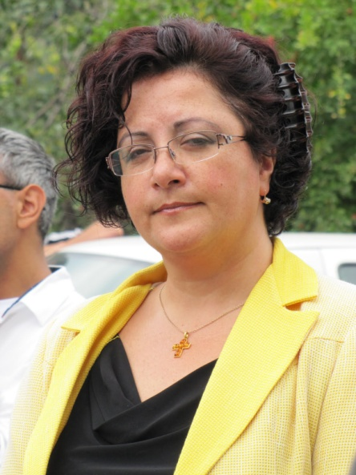 Dr. Arevik Sargsyan
Arevik Sargsyan was born in 1965 in Armenia, graduated Yerevan High School after A.Chekhov with excellent marks, graduated Polytechnic University in 1987 with Honor Diploma (was a Lenin Fellowship Student). She is Doctor of Engenireeng, has more than 170 printed scientific and methodological articles, 4 books, 2 patents. She was a supervizer of 80 Bachaler Degree, 22 Master Degree and 5 Ph.D. Degree Students. For now she is working on Doctoral Degree Thesis on Andragogy.
Arevik Sargsyan is multi professional, has three specialities: Radio Engineer, Business Trainer and Consultant, Adult Education (Andragogy) Professional. The main occupation is National Polytechnic University of Armenia (NPUA) – 26 years experience, Associated Professor. She is owning and managing ARLIAN consulting and Training Company for 21 years, and was elected many times during last 10 years as a President of Adult Education and Lifelong Learning Association (NGO, Armenia). Arevik Sargsyan is a Member of Council of the Ministry of Education and Science of RA, Member of the Board of the Civil Cooperation Network for Armenia Development Strategy (ADS CCN), Full Member of Armenian Business Trainers Association.
As a National Expert and Trainer she was engaged in projects of World Bank, USAID, UNDP, ETF, SME DNC, NC VETD, ANQA, State Employment Agency and others. She was invited as a Speaker, International Expert, Trainer to Russia, USA, Germany, Greece, Norway, India, Sweden, Denmark, Grate Britain, Brazil, Spain, Italy, Kirgizstan, Belarus, Moldova.
Arevik Sargsyan was awarded by RA Prime-minister Prize “Best Business woman in 2013 year” for the nomination of Innovation and Initiative.
She has one Son 24 years old.

